Consider your colleagues

Accessibility is for everyone

This document contains the content included in posters created for Global Accessibility Awareness Day to put up around IT Services buildings. There are seven fictional colleague profiles that provide a sense of the diverse preferences and needs that should be considered when collaborating with colleagues and some guidance on good practices that make the workplace more accessible and inclusive for all.

My name is *Drew*  2

My name is *Krish*  3

My name is *Immaculate*  4

My name is *Amira*  5

My name is *Sam*  6

My name is *Faren*  7

My name is *Ros*  8

# My name is *Drew \**

I am a **Database Administrator** involved in maintaining our systems infrastructure

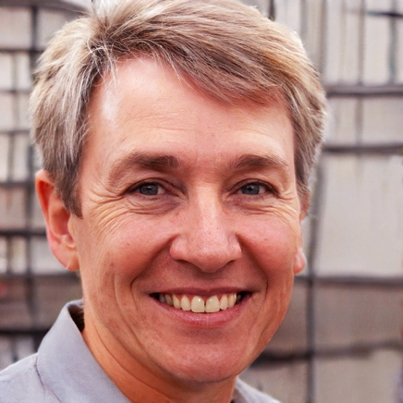

## Profile and preferences

I have a busy professional life and am constantly context switching when working on variety of projects and implementations.

I am hard of hearing and can lip-read. I can get frustrated when colleagues forget I struggle with them talking fast. In the past I have also suffered with bouts of depression.

## Colleague considerations

### Benefits from:

* Social chat opportunities or coffee catch-ups – in office or virtual
* Use of closed captions in Teams meetings
* Circulated minutes to review meeting content they may have missed
* Recorded Teams meetings
* Colleagues having cameras turned on during video calls so they can lip-read

Avoid:

* Audio or video only content
* Complicated words or figures of speech
* Everyone having microphones turned on during large Teams calls
* Unrealistic deadlines

# My name is *Krish \**

I am a **Finance Assistant** working on purchasing and supplier invoices

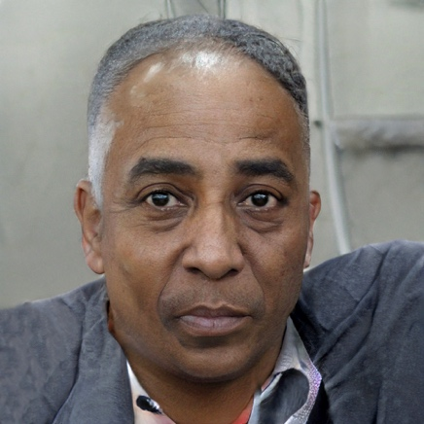

## Profile and preferences

I am a holistic thinker who likes to understand the big picture.

I am colour blind and get frustrated when my co-workers use colour to convey meaning in graphs or presentations.

I also have poor manual dexterity and prefer to use the keyboard over the mouse where possible.

## Colleague considerations

### Benefits from:

* Plain text emails
* High contrast colour ratios in staff communications
* Alt text descriptions of colourful graphics in meetings/presentations
* Software/websites that support keyboard navigation

Avoid:

* Using colour to convey information in documents/emails, including when replying 'in-line'
* Complicated spreadsheet templates which can't be accessed with a keyboard
* Mouse-only interactions

# My name is *Immaculate \**

I am a **Senior Developer** working on implementing a new web application

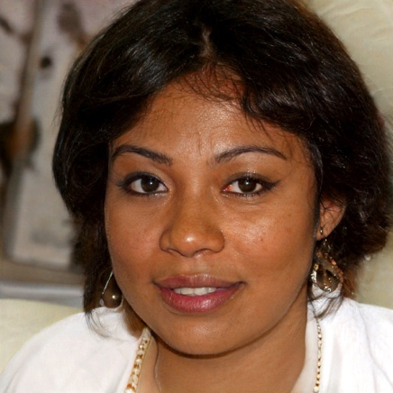

## Profile and preferences

I'm a multi-tasker; happiest when working on several things at once. The nature of my project work means I'm often involved in large group meetings.

I was recently diagnosed with ADHD and I'm still trying to figure out what support I need at work.

I am colour blind and get frustrated when my co-workers use colour to convey meaning in graphs or presentations.

I also have poor manual dexterity and prefer to use the keyboard over the mouse where possible.

## Colleague considerations

### Benefits from:

* Regular breaks during long meetings or between back-to-back sessions
* Clear concise language
* Meeting minutes with defined actions
* Wearing headphones when working in a large office to limit noise distractions
* Clear meeting agenda and good time-keeping

Avoid:

* Large blocks of text in emails
* Posting unnecessary content in chat during Teams meetings
* Calling without checking their availability first (e.g., via a quick chat message)

# My name is *Amira \**

I am a **Project Manager** overseeing the day-to-day management of a new customised desktop application



## Profile and preferences

I was diagnosed with dyslexia as a child, and I can still sometimes feel overwhelmed by incoming information.

I find it much easier when interacting face-to-face or verbally with my colleagues. Sometimes I also use a screen-reader when digesting large documents.

## Colleague considerations

### Benefits from:

* Large, clean fonts (e.g. Arial, Helvetica, Verdana) – ask their preference
* Concise, well structured content
* In-person / Verbal interaction with colleagues
* Hard copy, printed resources (ideally on coloured paper)
* Providing meeting agendas in advance

Avoid:

* Justified text​
* Large blocks of text in documents/emails – use headings and space
* Serif fonts (e.g., Brush Script) and italicised text
* Double negatives and abbreviations in documents
* Pressurising them into taking meeting notes

# My name is *Sam \**

I am an **IT Support Specialist** handling technical desktop queries

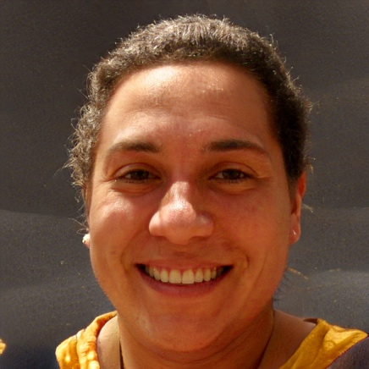

## Profile and preferences

I often deal with complex technical queries and user problems in a time-pressured environment.

I have high-functioning autism and am detail-orientated.

I dislike idiomatic language.

## Colleague considerations

### Benefits from:

* Plain language
* Concise, well structured content
* Predictability and consistency
* Dedicated personal desk in the office

Avoid:

* Bright, contrasting colours
* Idiomatic language
* Auto-playing media content
* Icons without accompanying text or explanation
* Sudden changes to expectations
* Attending meetings late

# My name is *Faren \**

I am a **Portfolio Analyst** working on improving business processes within IT Services

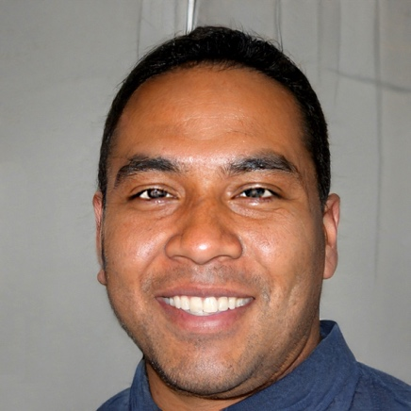

## Profile and preferences

I am methodical and process driven. I like to work on one task at a time.

I have an inherited eye disorder and am registered as sight impaired.

I find it helpful to use a use a screen-reader on desktops and mobile devices.

## Colleague considerations

### Benefits from:

* Colleagues providing self-descriptions at start of meetings
* Descriptive alt texts for images
* Large fonts in emails with clear headings
* Tables explicitly marked up as tables in emails and documents
* Videos with audio-descriptions

Avoid:

* Sharing images in Teams chats without appropriate descriptions
* Using only Teams chat to collect participants votes/responses
* Images of text in presentations, emails and documents
* Saying 'Can everyone see my screen?’; instead say 'Can everyone see the screen who needs to?’
* Visually dependent content

# My name is *Ros \**

I am an **IT Teacher** running sessions to train staff and students on specialist research software

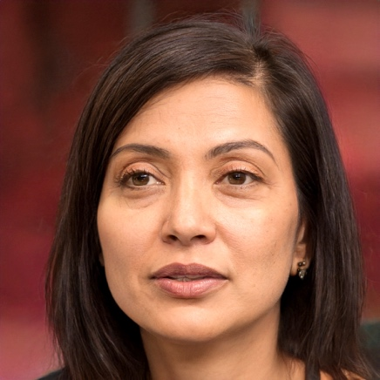

## Profile and preferences

I love engaging with people and instilling a sense of confidence in them through my teaching.

I suffer with rheumatoid arthritis which can make it uncomfortable for me to sit for long periods of time and I can struggle with stairs.

On my bad days I find it easier to use Dragon voice-to-text to dictate my emails.

## Colleague considerations

### Benefits from:

* Regular breaks scheduled in meetings
* Software/websites that work with just a keyboard
* Quiet offices when using Dragon
* Dedicated personal desk space with ergonomic mouse/keyboard and supportive chair
* Colleagues offering to take meeting minutes

Avoid:

* Long forms/surveys
* Messaging over chat – prefers to talk over the phone or in person
* Complicated spreadsheet templates
* Inaccessible meeting rooms
* Open windows creating drafts